Andrew Chen 2026 04 15
Report for EMG Lab
Follow the Colab file “HSI Lab 7 – EMG.ipynb” and record your process and results in this document.
* For each step, provide sufficient explanation of the process of reaching the final result or plot
* For each plot to report, include proper axis labels and units. For each numerical result to report, include proper units
- Load Raw Data
What I did: loaded in the txt file and generataed a time axis by dividing length of signal by sampling frequency
Plot: 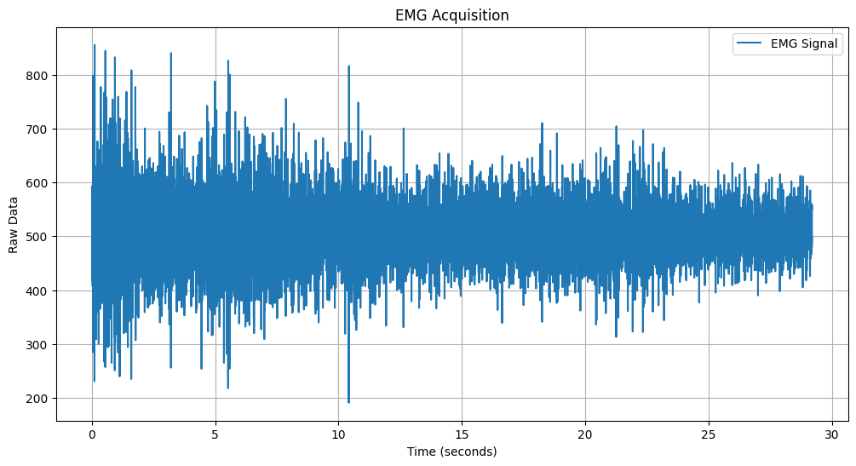

- Apply band-pass filter
What I did: According to my brief research, the dominant frequency band for this task lies in between 50-100 Hz. So, I used this frequency band for my band-pass filter.
Plot: 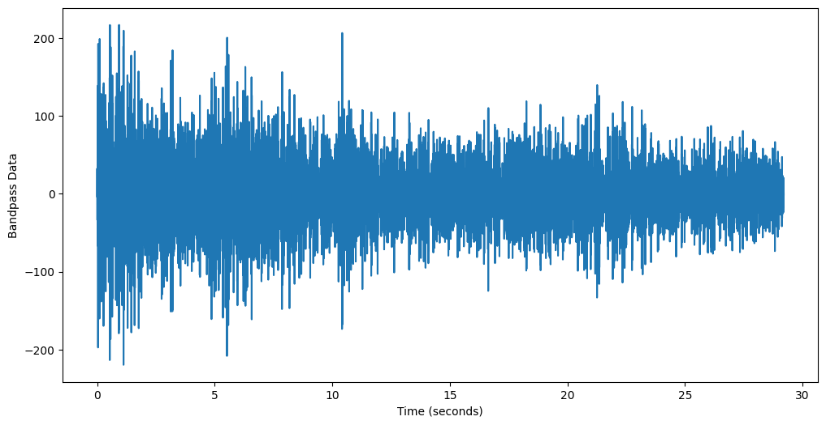

- Frequency-based visualization
What I did: After filtering, I performed a FFT and plotted a spectrogram.
Plot: 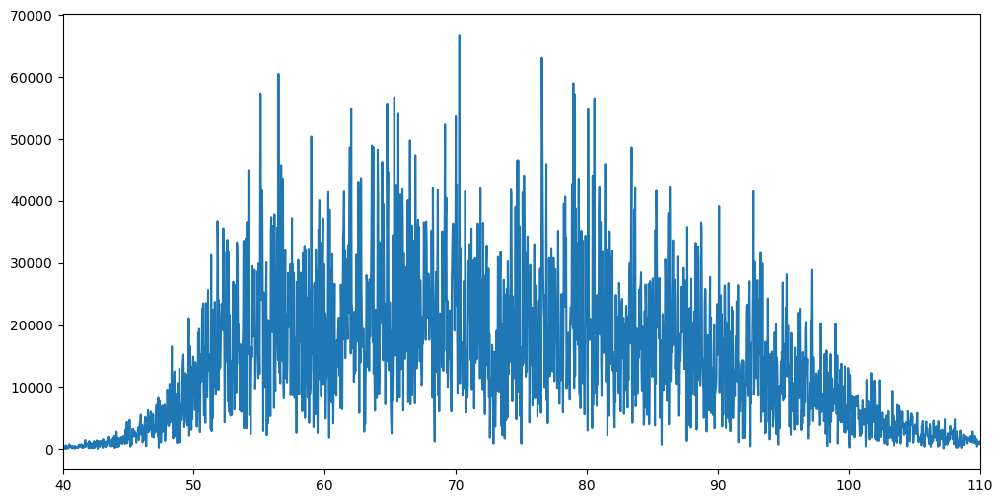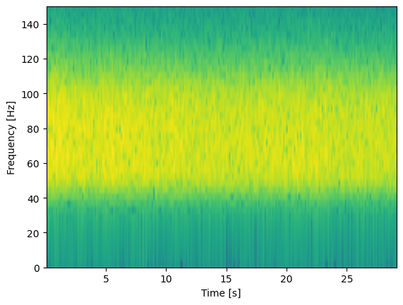
What I observed:
I saw a broad distribution of frequencies within the frequency band I selected.

- Data rectification
What I did: Took the absolute value of all the data points.
Plot: 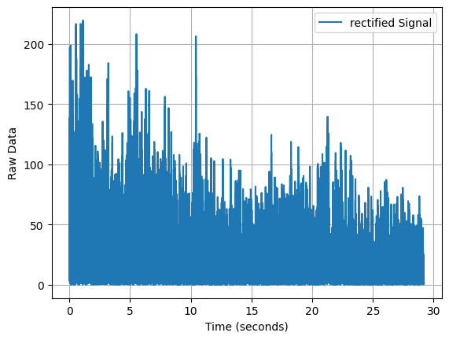

- Integrated EMG Calculation
What I did: What I did: I calculated iEMG by computing the area-under-the-curve of the rectified signal.
Result: 263.9

- Change of iEMG w.r.t. weight (Alternative scenarios processing)
What I did: I repeated the processing pipeline for the data files corresponding to three different weights: 1060g, 2670g, and 3885g
Results:
[(1060, 106.08689115194903),
(2670, 211.00123250647536),
(3885, 263.9037505979368)]
Plot:
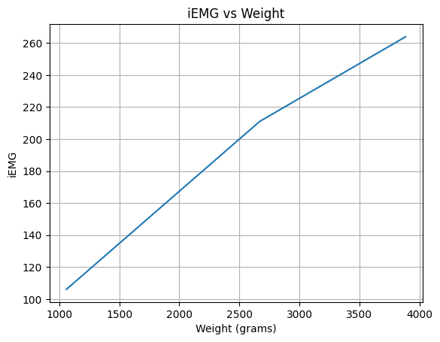
What I observed:
There seems to be a positive correlation between the weight lifted and the iEMG value. As the weight increased, the iEMG increased, which makes sense, as lifting heavier loads requires more muscle activation and therefore higher firing rates.

- Discussion
Comment on the differences in analyzing EMG signals vs other signals like ECG:
Unlike ECG signals, EMG signals are stochastic in appearance. This is because EMG measures the sum of all muscle activations, which fire simultaneously. While ECG analysis often focuses on peak detection for heart rate, EMG analysis focuses on amplitude and power to quantify muscle force and fatigue.
- Link to Colab file: [Make sure to grant file access to “anyone with the link” to make sure TAs have access to the code]

